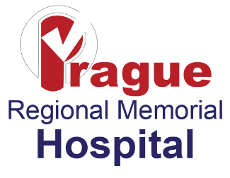
Financial Assistance Plain Language Summary
Prague Regional Memorial Hospital provides free or discounted emergency and other medically necessary care to patients who are uninsured or underinsured and who qualify for assistance under its Financial Assistance Policy. Assistance does not apply to elective services or items that are solely for the comfort or convenience of a patient. This document is only a summary. Please refer to the Financial Assistance Policy for complete details.
Eligibility Requirements and Assistance Offered:
Eligibility for financial assistance is based on many factors including the nature of the condition and care required, insurance coverage or other sources of payment, income, family size, assets, and any special considerations the patient would like to have considered.
Patients seeking financial assistance must comply with the Financial Assistance application process. This includes submitting the patient’s W-2 statement, current pay stubs, bank statements or last year’s income tax return, and completing the application process for all available sources of assistance, including state subsidized care (Medicaid).
A patient who qualifies for assistance under the Financial Assistance Policy will not be charged more for emergency or medically necessary care than amounts generally billed to patients having insurance covering such care.
How to Obtain Copies of the Financial Assistance Policy and Financial Assistance Application Copies of the Financial Assistance Policy, this plain language summary, and the Financial Assistance Application and associated instructions are available on the hospital website. Alternatively, printed copies of the hospital’s Financial Assistance can also be found by calling or visiting the hospital business office or the hospital’s main registration area.
How to Apply: Any patient may apply to receive financial assistance by submitting an application and providing supporting documentation. If you have questions, need help, or would like to receive an application form or more information, please contact us:
- By Telephone: (405) 567-4922
- On our website at: www.prague.hospital
- In person: Facility Business Office or Registration Area(s)
- To obtain documents via mail free of charge please call our business office at the number above to request.
A Spanish version of the application form, financial assistance policy and this summary are available upon request.

